Friday, 4 September 2026, postcard

Waxy O'Connor's and The Book of Mormon

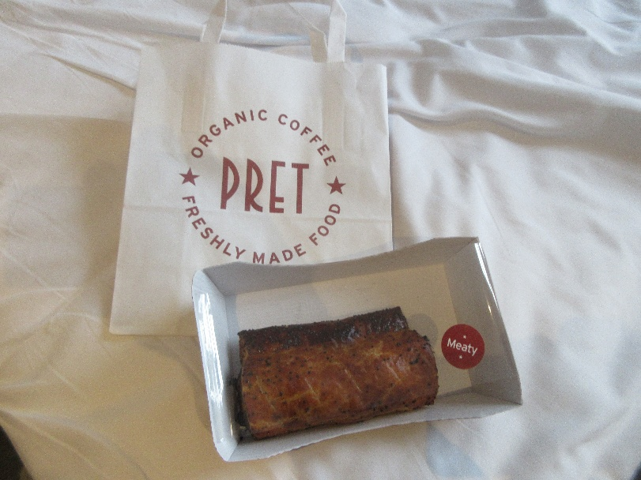
David wanted to sleep in, so I was on my own for breakfast. A web search of the neighborhood turned up precious few possibilities (now, I ask you, what good is a bakery/donut shop that doesn't open 'til 11 am?!), but I headed hopefully off on foot in the rain. Well, the weather forcast said it was raining, but it would not have qualified as such in Tallahassee. The drops didn't so much fall on you as hover in the air, where you collided with them as you walked. Anyway, only a long block from the hotel, I found (recessed back under a lot of construction scaffolding) a Pret A Manger ("ready to eat"), a chain as thick on the ground here as Starbucks in the U.S. There I acquired a warm, crispy, puff-pastry sausage roll, which I took back to the hotel and made myself a cup of tea.

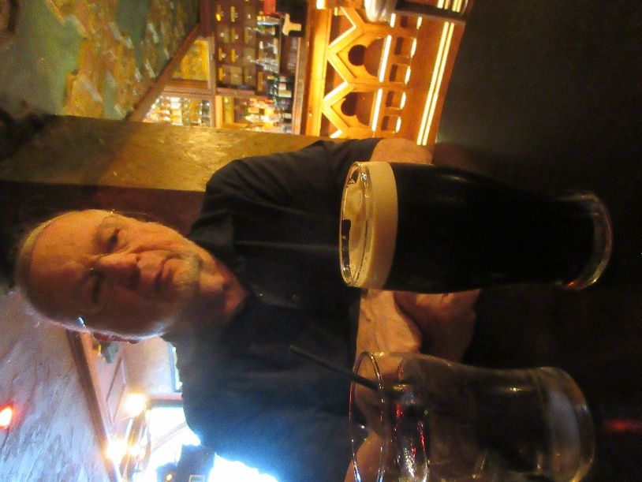
At noon, as agreed, David emerged, and we set off, prospecting for lunch, toward The Prince of Wales Theatre. From my list of possibilities, David selected Waxy O'Connor's Irish Pub. He's been looking for real ales and wanted a pint of bitter, but the best he could do was a Murphy's stout (aside from that and Guiness, all they had was lagers).

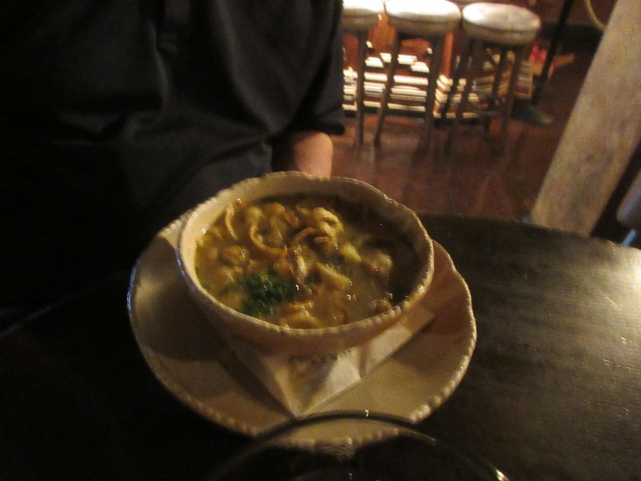
David had a big bowl of baked potato and leek soup. I chose the cider-battered fish and chips, with tartare sauce and mushy peas. The fish was real cod, and the coating shatteringly crisp. Excellent rendition.

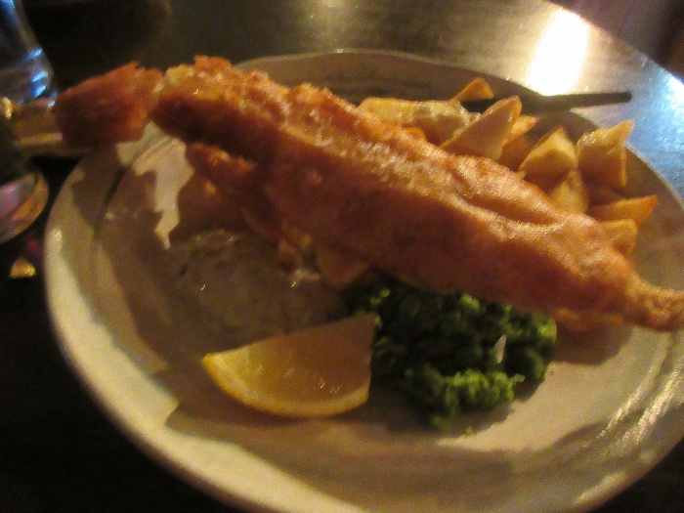
The photos are kind of blurry because the light was so low.

Our matinée of The Book of Mormon at the Prince of Wales was at 2:30 pm, so we got there in plenty of time. I paused to admire a wonderful Art Deco building nearby, decorated with a fountain featuring statues four rearing and plunging horses, as well as golden stylized women diving from the roof. Unfortunately, it's a Hard Rock Café now.

The theater itself is surprisingly shallow, front to back. We were in the fifth row, and the row behind us was already under the front row of the balcony!

The play was very funny, in a black-comedy sort of way, and I enjoyed it thoroughly. I had forgotten the bit of Mormonism that says Jesus spent the three days between the crucifixion and the resurrection preaching in upstate New York.

On the way back, David said I was also on my own for dinner. He wasn't feeling great and wanted to go back to bed. We must be getting old, as it seems jet-lag throws us both for a bigger loop than it used to.
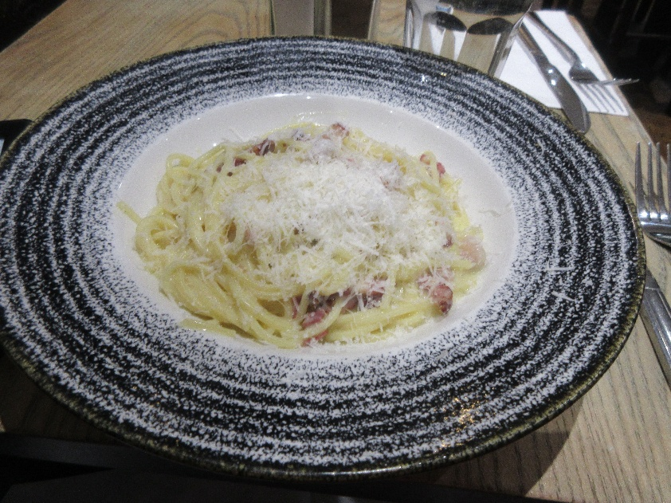
Anyway, I went to Bella Italia, a couple of doors down, for a bowl of pasta carbonara and a decaf affogato. That's vanilla ice cream with a shot of hot espresso poured over it.
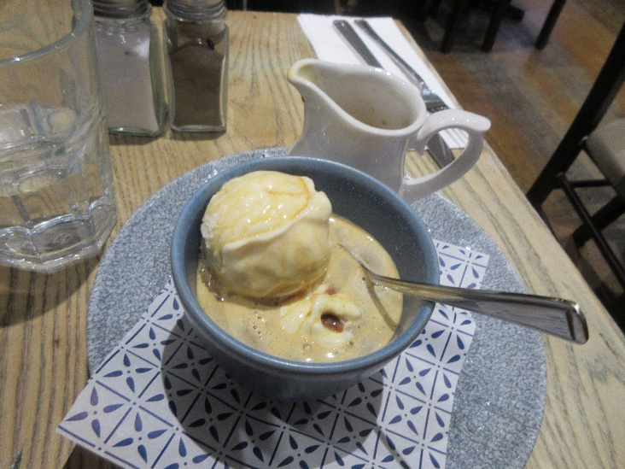

I'll be on my own for breakfast again tomorrow . . . .

